***PROJECT REPORT ON WEBSITE***

NSCBM GOVT DEGREE COLLEGE HAMIRPUR



PRESENTED BY:

* SHIVANSHU
* RITIK RANA
* ANITA
* NITIKA

PRESENTED TO

Department Of Computer Application

N.S.C.B.M Govt Degree College

Hamirpur (H.P)-177005

***CERTIFICATE***

This is to certify that “**WEDDING PLANNER WEBSITE** “embodies the original work done by **SHIVANSHU, ANITA , RITIK RANA, NITIKA** . This project is developed only on the basis of individual knowledge of students which they have learnt during BCA Programme in this college.

The project is developed in partial fulfillment of degree of Bachelor of Computer Application.

It is further certified that all the members of this group played their complete role as group members for developing this project.

***\***

**Dr. LAVLI RANA Prof. Pankaj Kumar**

(Co-ordinator of BCA) (Project Guide)

**DECLARATION**

*We hereby declare that the project work titled “Wedding Planner Website” is authentic work carried out by us under the guidance of Prof. Pankaj Kumar and Dr. Lavli Rana (H.O.D) of Dept. of Computer Applications of N.S.C.B.M. Govt. College Hamirpur.*

***NAME SIGNATURE***

* ANITA (6210360008) …………………………
* NITIKA (6210360026) …………………………
* RITIK RANA (6210360031) …………………………
* SHIVANSHU (6210360036) …………………………

DATE:____________

CLASS : BCA 6TH Semester

DEPARTMENT : BCA

PROJECT GUIDE : Prof. Pankaj Kumar

COLLEGE : N.S.C.B.M. Govt. College Hamirpur

**ACKNOWLEDGEMENT**

*A computer professional course is incomplete without the development of a project along with the theoretical studies as it strengthens the confidence of students in their work fields enables them to correlate the theoretical knowledge with practical environment.*

*Having considered the above statement, we were decided to make a “WEDDING PLANNER WEBSITE named 7PROMISES” for our project development using VISUAL STUDIO CODE, REPLIT as development tools.*

*The completion of any project involves the contribution and cooperation of many people who are responsible for the creation of congenial atmosphere where all the problems can be solved easily. It gives us tremendous pleasure in acknowledging valuable assistance extended to us by various personalities in successful completion of the project.*

*We are sincerely Thankful to Prof. Pankaj Kumar who helped us in accomplishing our project and always remained ready to solve our doubts.*

**PROJECT PROFILE**

|  |  |
| --- | --- |
| Object | Content |
| * ORGANISATION | “BCA 6th sem  Govt College Hamirpur” |
| * PROJECT TITLE | “Wedding Planner Website named 7PROMISES” |
| * OBJECTIVE | This Website Provide Facility of Booking Wedding Planners and Decoraters at our Wedding Destination Venues. |
| * FRONT END | HTML, CSS And JAVASCRIPT |
|  |  |
| * INTERNAL GUIDE | PROF. PANKAJ KUMAR  OF DEPT. OF COMPUTER  APPLICATION |

**INTRODUCTION**

1. **TO HTML:** Hyper Text Markup Language or HTML is the standard markup language for documents designed to be displayed in a web browser. It defines the content and structure of web content. It is often assisted by technologies such as Cascading Style Sheets (CSS) and scripting languages such as JavaScript.
2. **TO CSS:** Cascading Style Sheets (CSS) is a style sheet language used for specifying the presentation and styling of a document written in a markup language such as HTML or XML (including XML dialects such as SVG, MathML or XHTML).
3. **TO JAVASCRIPT:** JavaScript is a lightweight, cross- platform, single-threaded and interpreted compiled programming language which is also known as scripting language for webpages. It is well known for the development of webpages, and many non-browser environments also use it. It contains a standard library of objects like array, date, and math and a crore set of language elements like operators, control structure and statements.

**NEED OF WEBSITE**

1. User can book Wedding Planners and Decorators for their wedding.
2. Through this user can choose their destinations for wedding.
3. User can get bridal makeup artists, jewelries, groom wears etc. on rent.
4. Vendors can register here for various services.

**FUNCTIONAL SPECIFICATION**

**Module of the system:**

1. REGISTRATION
2. LOGIN
3. ONLINE BOOKING FOR SERVICES
4. E-INVITATIONS DESIGNS
5. PAYMENTS

**USER OF THE SYSTEM**

* ***ADMIN-***
* Admin can manage overall website and user profile.
* Add/Delete/Modify services and vendor types.
* Manage user and registered vendor information.
* To generate the various reports.
* ***USER-***
* User can register in site.
* User can search for various services details.
* User can modify his/her profile.
* User can book the services online.
* User can make online payments.
* User can give feedback.

***HARDWARE AND SOFTWARE REQUIRMENTS***

**(MINIMUM REQUIRMENTS)**

CLIENT SIDE HARDWARE REQUIRMENTS

* PROCESSOR : Processor 1.6 GHz
* RAM : 1GB
* HARD DISK : Minimum 20 GB

CLIENT SIDE SOFTWARE REQUIRMENTS

* OPERATING SYSTEM : Window 7,8,10 or Any equivalent operating system.
* BROWSER : Any compatible browser.

Server side hardware requirments

* PROCESSOR : Processor 1.6 GHz
* RAM : 1GB
* HARD DISK : Minimum 20 GB

Server side software requirments

* OPERATING SYSTEM : Window 7,8,10 or Any equivalent operating system.
* BROWSER : Any compatible browser.

# Time line chart

Activity Diagram for user

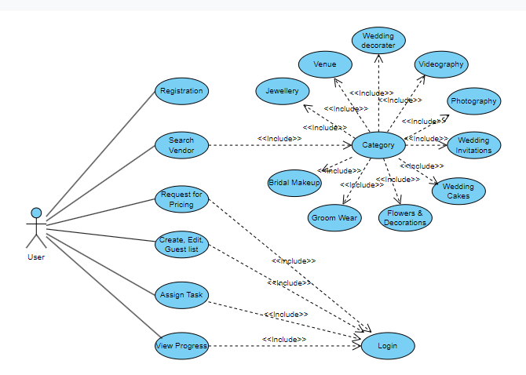

USE CASE DIAGRAM FOR USER

Activity Diagram for admin

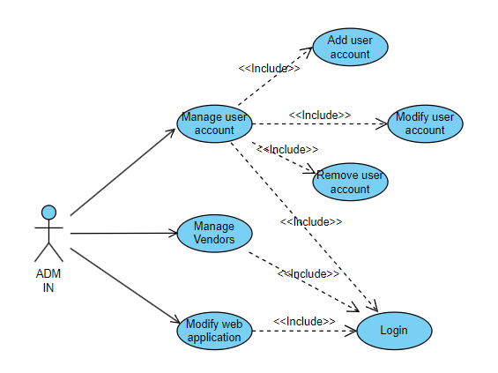

USE CASE DIAGRAM FOR ADMIN

Activity Diagram for vendor

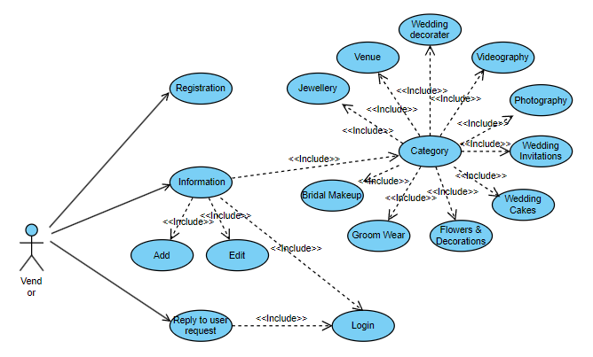

USE CASE DIAGRAM FOR VENDOR

# Software

# Development

# Life

# cycle

**REQUIREMENT ANALYSIS**

Requirement analysis is done to know what the requirement of the user is. It mainly deal with to understand the problem, after understanding the problem its necessary to go for studying the existence system for this analyst move to the system analysis phase.

System analysis is a process of studying the whole process, generally referred to as system, to see how the improvement is needed.

This may involve data moment, storage, machine and technology uses in a system program that control machines, people providing inputs, doing the processing and retrieving the outputs.

**INITIAL INVESTIGATION PHASE**

The investigation phase is also known as fact finding stage or analysis of current system. This is the detail study conducted with the purpose to fully understand the existing system to identify basic information. Various techniques are used for investigation like Questionnaire.

Depending on the results to the initial investigation the survey is now expanded to more detailed feasibility study. ”FEASIBILITY STUDY” is the test of system proposal according to its work ability, impact of the organization, ability to meet needs an effective use of the resources. It focuses on these major questions:

1. What are the user needs and how does a candidate system meet them?
2. What are resources available for given candidate system?
3. What are likely impacts of the candidate system on the organization?

**TYPES OF FEASIBILTY STUDY**

* **TECHNICAL FEASIBILTY**

It is the study where the main problem is defined. Here all requirements of resources or demands are identified. This is the first step of feasibility study. This evaluation determines whether the technology needed for the purposed system is available or not.

* **ECONOMICAL FEASIBILTY**

Economic justification is generally the “bottom line” consideration for most systems. Economic justification includes post benefits analysis. In this we weight the cost and benefits associated with the candidate system and if it suits the basic purpose of the organization i.e. profit making.

* **OPERATIONAL FEASIBILTY**

It is the mainly related to human organization and political aspects. The points to be considered are:

What changes will be brought with system?

What new skills will be required?

What organization structures are disturbed?

Do the existing staff members have these skills? If not, can be they trained due course of time? The system is operationally as it very easy for the end user to operate it. It only need basic information of windows platform.

* **SCHEDULE FEASIBILTY**

Time evaluation is the most important consideration in the development of project. The time schedule required for the project is very important since more development time effect machines time, cost and cause delay in the development of the other systems. A reliable Wedding Planner Website can be developed in the considerable amount of time.

**IMPLEMENTATION**

It is one of the main modules of the project development stage. All the work done as earlier comes near to end when I am going to implementing the project. I tried my best to fulfill all the requirements of the WEDDING PLANNER WEBSITE. However, implementation can be taken finalize the testing procedure. But if we implement the project there is not any standardized procedure to check testing while I implementation give us chance to test if there is any problem, it can be taken remedies so we can finalize the project, using implementation and reviewing techniques. So far, this project is concerned; it is free from errors and can be implemented very effectively.

**Coding phase**

Code design view and outputs

1. **Open the Visual Studio Code platform.**

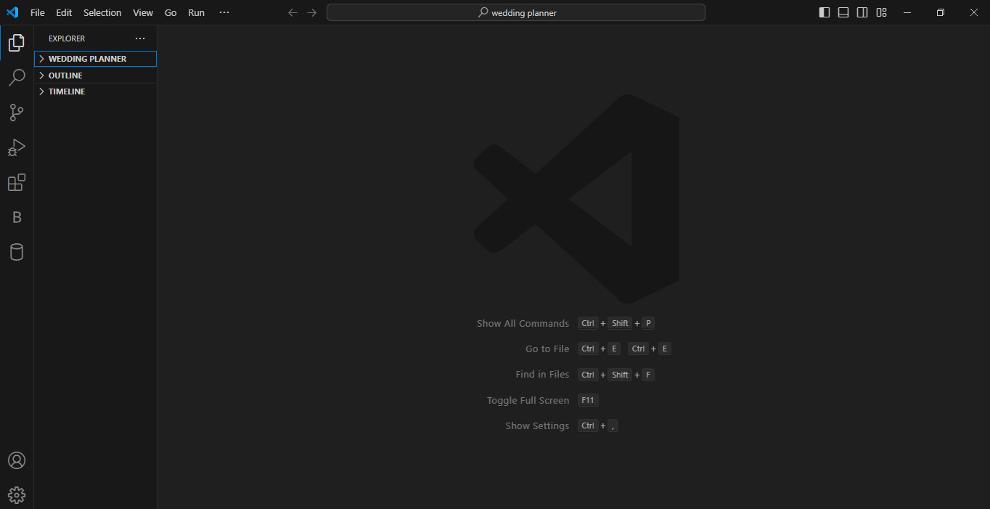

1. **START CODING**

**MAIN PAGE CODING**

<!DOCTYPE html>

<html lang="en">

<head>

<meta charset="UTF-8">

<meta http-equiv="X-UA-Compatible" content="IE=edge">

<meta name="viewport" content="width=device-width, initial-scale=1.0">

<title>7 Promises-Wedding-Planner</title>

<link rel="shortcut icon" href="logo.png" type="image/x-icon">

<link rel="stylesheet" href="style.css">

<link rel="stylesheet" href="https://cdnjs.cloudflare.com/ajax/libs/font-awesome/5.15.4/css/all.min.css">

</head>

<body>

<header class="head">

<img src="import.jpeg" class="my-logo"></img>

<nav class="navbar ">

<a href="#" class="active">Home</a>

<a href="#service">Service</a>

<a href="#vendor">Vendors</a>

<a href="#invite">Card Design</a>

<a href="#contact">Contact Us</a>

</nav>

<div id="menu-bar"><i class="fas fa-bars"></i></div>

</header>

<section class="home" id="home">

<form action="#">

<div class="search-box">

<h1>Welcome My Website</h1>

<p>Find the best wedding vendors with thousands of trusted reviews</p>

<select id="vendor-select" type="text" class="search-field">

<option disabled selected>Select vendor type</option>

<option value="bridal makeup">Bridal Makeup</option>

<option value="GroomWear">Groom Wear</option>

<option value="Wedding Decoration">Wedding decoration</option>

</select>

<select id="city-select" type="text" class="search-field">

<option disabled selected>City</option>

<option value="Hamirpur">Hamirpur</option>

<option value="palampur">Palampur</option>

<option value="kangra">Kangra</option>

</select>

<button id="search-button" class="btn" >Search</button>

</div>

</form>

</section>

<section class="service" id="service">

<div class="title">

<h1><span>S</span>ervice</h1>

</div>

<div class="services-row">

<div class="services-col">

<i class="fas fa-book-open" style=" margin-left: 66px;

margin-top: 20px;

"></i>

<h2 style=" margin-left: 66px;">invitation</h2>

</div>

<div class="services-col">

<i class="fas fa-camera" style=" margin-top: 20px;

margin-left: 73px;"></i>

<h2 style=" margin-left: 24px;">Photography & Video</h2>

</div>

<div class="services-col">

<i class="fas fa-brush" style=" margin-left: 78px;

margin-top: 20px;"></i>

<h2 style="margin-left: 33px;">Beauty & Makeup</h2>

</div>

<div class="services-col">

<i class="fab fa-pagelines" style=" margin-left: 78px;

margin-top: 20px;"></i>

<h2 style="margin-left: 30px;">Wedding flowers</h2>

</div>

<div class="services-col">

<i class="fas fa-birthday-cake" style=" margin-left: 78px;

margin-top: 20px;"></i>

<h2 style="margin-left: 45px;">wedding cake</h2>

</div>

<div class="services-col">

<i class="fas fa-music" style=" margin-left: 78px;

margin-top: 20px;"></i>

<h2 style="margin-left: 59px;">music band</h2>

</div>

<div class="services-col">

<i class="fas fa-utensils" style=" margin-left: 78px;

margin-top: 20px;"></i>

<h2 style="margin-left: 70px;">Catering</h2>

</div>

<div class="services-col">

<i class="fas fa-ring" style=" margin-left: 78px;

margin-top: 20px;"></i>

<h2 class="first" style="margin-left: 75px;">Jewellery</h2>

</div>

</div>

</section>

<section class="vendor" id="vendor">

<div class="title">

<h1><span>F</span>eatured <span>V</span>endor</h1>

</div>

<div class="vendor-list">

<div class="vendor-row">

<div class="rate">4.5&nbsp;<i class="fa fa-star" aria-hidden="true"></i></div>

<img src="makeup.webp"alt="img">

<h2>Beauty tales by Neha Rawal</h2>

<p>Bridal Makeup</p>

<h3>Rs.10,000 onwards</h3>

</div>

<div class="vendor-row">

<div class="rate">4.2&nbsp;<i class="fa fa-star" aria-hidden="true"></i></div>

<img src="Flinter.jpeg""img">

<h2>Flinters Management</h2>

<p>Wedding Planner</p>

<h3>Rs.2.5-4 Lakh</h3>

</div>

<div class="vendor-row">

<div class="rate">5.0&nbsp;<i class="fa fa-star" aria-hidden="true"></i></div>

<img src="mela.jpg" alt="img">

<h2>Wedding Mela</h2>

<p>Wedding Decorators</p>

<h3>Rs.80,000-2,00,000</h3>

</div>

<div class="vendor-row">

<div class="rate">4.1&nbsp;<i class="fa fa-star" aria-hidden="true"></i></div>

<img src="Heaven.png" alt="img">

<h2>SeventhHeaven Wedding Company</h2>

<p>Wedding Decorators-Rental Only</p>

<h3>Rs.80,000 Onwards</h3>

</div>

<div class="vendor-row">

<div class="rate">4.3&nbsp;<i class="fa fa-star" aria-hidden="true"></i></div>

<img src="mela2.jpg" alt="img">

<h2>Wedding Mela</h2>

<p>Wedding Decorators</p>

<h3>Rs.80,000-1,00,00</h3>

</div>

<div class="vendor-row">

<div class="rate">4.0&nbsp;<i class="fa fa-star" aria-hidden="true"></i></div>

<img src="mela3.webp"img">

<h2>Wedding Mela</h2>

<p>Wedding Decorators</p>

<h3>Rs.1.8 Lakh</h3>

</div>

</div>

</section>

<section class="guest-list" id="guest-list">

<div class="title">

<h1>Guest <span>List</span> Upload</h1>

<p>Upload your guest list as photos</p>

</div>

<div class="guest-list-upload">

<form action="#">

<input type="file" id="guest-list-file" accept="image/*" multiple>

<label for="guest-list-file">Choose files</label>

<button class="btn" type="submit">Upload</button>

</form>

</div>

</section>

<section class="invite" id="invite">

<div class="title">

<h1>Card<span>Design</span></h1>

<p>Choose the best card Design.</p>

</div>

<div class="invitation-row">

<div class="invitation-box">

<img src="card6.jpg" >

</div>

<div class="invitation-box">

<img src="card10.jpg" alt="">

</div>

<div class="invitation-box">

<img src="https://img.freepik.com/free-psd/wedding-invitation-greeting-cards-elegant-vintage-style_1340-49454.jpg?size=626&ext=jpg" alt="">

</div>

<div class="invitation-box">

<img src="https://img.freepik.com/free-vector/indian-wedding-invitation_52683-44378.jpg?size=626&ext=jpg" alt="">

</div>

<div class="invitation-box">

<img src="card12.jpg" alt="">

</div>

<div class="invitation-box">

<img src="card7.jpg" alt="">

</div>

<div class="invitation-box">

<img src="https://img.freepik.com/free-vector/gradient-wedding-invitations-spanish_52683-81134.jpg?size=626&ext=jpg" alt="">

</div>

<div class="invitation-box">

<img src="https://img.freepik.com/free-vector/abstract-watercolor-wedding-invitation_23-2149069669.jpg?size=626&ext=jpg" alt="">

</div>

<div class="invitation-box">

<img src="card13.jfif" alt="">

</div>

<div class="invitation-box">

<img src="https://img.freepik.com/free-psd/wedding-invitation-greeting-cards-elegant-vintage-style_1340-49374.jpg?size=626&ext=jpg&ga=GA1.1.1580806941.1707068233&semt=ais" alt="">

</div>

<div class="invitation-box">

<img src="https://img.freepik.com/free-vector/gradient-wedding-invitation-template_23-2148889950.jpg?size=626&ext=jpg&ga=GA1.1.1580806941.1707068233&semt=ais" alt="">

</div>

<div class="invitation-box">

<img src="card8.jpg" alt="">

</div>

</div>

</section>

<footer id="contact">

<div class="container">

<div class="f-container">

<h2>Wedding Planner - Your Personal Wedding Planner</h2><br>

<div>

<a href="Register as vendor/index.html"> <button class="btn">Register as a Vendor</button></a>

</div>

<div class="social">

<i class="fab fa-facebook"></i>

<i class="fab fa-instagram"></i>

<i class="fab fa-youtube"></i>

<i class="fab fa-twitter"></i>

</div>

</div>

<div class="f-container">

<h2>Our Location</h2>

<a href="#"><i class="fas fa-angle-right"></i>Hamirpur</a>

<a href="#"><i class="fas fa-angle-right"></i>Una</a>

<a href="#"><i class="fas fa-angle-right"></i>palampur</a>

<a href="#" "><i class=" fas fa-angle-right "></i>Kangra</a>

<a href="# "><i class="fas fa-angle-right "></i>Shimla</a>

<a href="# "><i class="fas fa-angle-right "></i>Chamba</a>

<a href="# "><i class="fas fa-angle-right "></i>Solan</a>

</div>

<form class="f-container " action="https://getform.io/f/raeqoxoa" method="post">

<h2>Contact Me</h2>

<p>Enter Your Name.</p>

<input type="text" name="name" id="" placeholder="Enter Your Name">

<p>Enter Your Email</p>

<input type="text " name="Email" placeholder="Enter Your Email ">

<p>Enter Your Add</p>

<input style="height: 100px;" type="text" name="text" id="" placeholder="Enter Your Add:">

<button class="btn ">Send</button>

</form>

</div>

</footer>

<div class="copyright ">

<p>Copyright &copy; 2024 Designed By bca students</p>

</div>

</body>

<script src="first.js"></script>

</html>

**LOGIN PAGE CODING**

<!DOCTYPE html>

<html lang="en">

<head>

<meta charset="UTF-8">

<meta name="viewport" content="width=device-width" , intial-scale="1.0">

<title>Log in Page</title>

<link rel="stylesheet" href="https://cdnjs.cloudflare.com/ajax/libs/font-awesome/5.15.4/css/all.min.css">

<link rel="stylesheet" href="stylee.css">

</head>

<body>

<section class="container">

<div class="image-section">

<div class="image-wrapper">

<img src="./mesh-gradient.png" alt="img">

</div>

<div class="content-container">

<h1 class="section-heading">Welcome To Your Trusted Wedding Planners<span>7Promises</span></span></h1>

<p class="section-paragraph">Creating unforgettable weddings with our seven promises of perfection.Embrace the

journey.</p>

</div>

</div>

<div class="form-section">

<div class="form-wrapper">

<div class="logo-container">

<a href="#" class="logo-container">

<img src="" alt="img">

</a>

</div>

<h2>Welcome!!!</h2>

<p>Enter your details to register</p>

<div class="input-container">

<div class="form-group">

<label for="email">Email</label>

<input type="email" id="email" autocomplete="off">

</div>

<div class="form-group">

<label for="password">Password</label>

<input type="password" id="password">

</div>

</div>

<div class="remember-forgot">

<div class="remember-me">

<input type="checkbox" value="remember-me" id="remember-me">

<label for="remember-me">Remember me</label>

</div>

<a href="#">Forgot password?</a>

</div>

<button class="login-btn">Log In</button>

<div class="or-divider">or</div>

<button class="google-signin">

<object data="./google.svg"></object>

<span>Sign in with Google</span>

</button>

</div>

</div>

</section>

</body>

<script src="scriptt.js"></script>

</html>

**JAVASCRIPT**

let menu = document.querySelector('#menu-bar');

let head = document.querySelector('.head .navbar');

menu.onclick = () => {

head.classList.toggle('active');

};

window.onscroll = () => {

head.classList.remove('active');

if (window.scrollY > 60) {

document.querySelector('#menu-bar').classList.add('active');

} else {

document.querySelector('#menu-bar').classList.remove('active');

}

}

const vendorSelect = document.querySelector('#vendor-select');

const citySelect = document.querySelector('#city-select');

const searchButton = document.querySelector('#search-button');

searchButton.addEventListener('click', () => {

const selectedVendor = vendorSelect.value;

const selectedCity = citySelect.value;

switch (selectedVendor) {

case 'bridal makeup':

switch (selectedCity) {

case'Hamirpur':

window.open("/bridalhamirpur/ndex.html");

break;

case 'palampur':

window.open('/Bridal makeup Palampur/index.html');

break;

case 'kangra':

window.open('/Bridal makeup Kangra/index.html');

break;

}

break;

case 'GroomWear':

switch (selectedCity) {

case 'Hamirpur':

window.open("/GROOM WEAR hamirpur/index.html");

break;

case 'kangra':

window.open('/Groom wear Kangra/index.html');

break;

case 'palampur':

window.open('/Groom wear palampur/index.html');

break;

}

break;

case 'Wedding Decoration':

switch (selectedCity) {

case 'kangra':

window.open('wedding decoration Kangra/index.html');

break;

case 'Hamirpur':

window.open('wedding decorations hamirpur/index.html');

break;

case 'palampur':

window.open('wedding decoration palampur/index.html');

break;

}

break;

}

});

**VARIOUS OUTPUT OF DESIGNED PROJECT**

**MAIN PAGE**

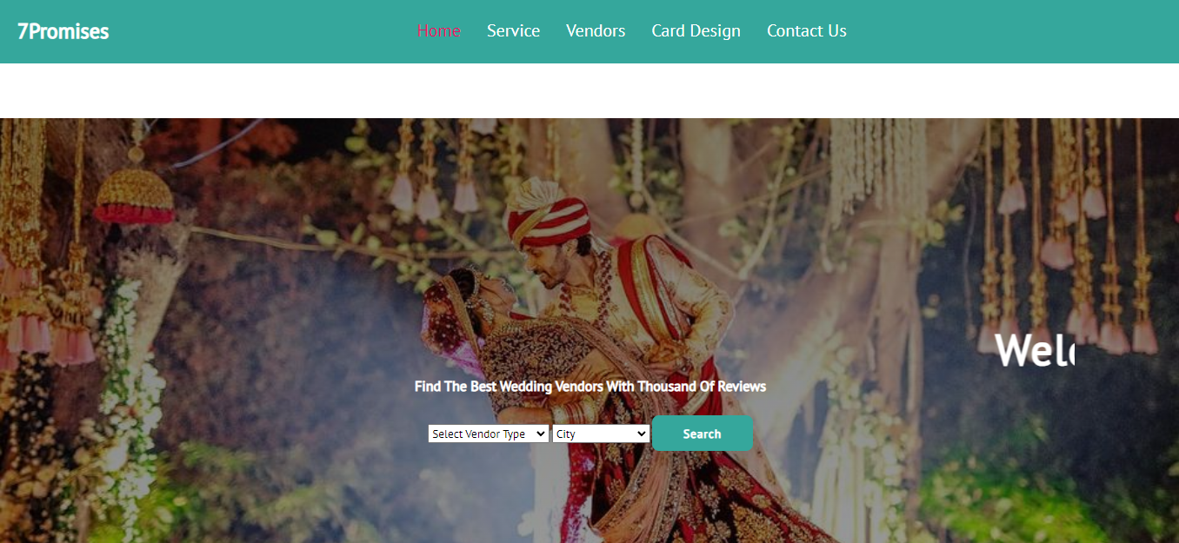

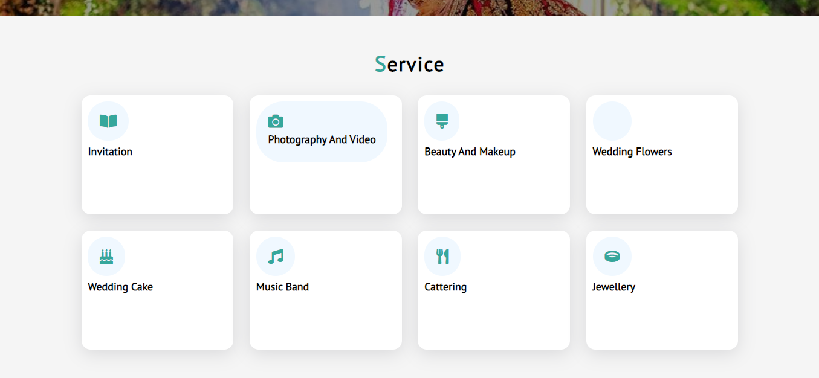

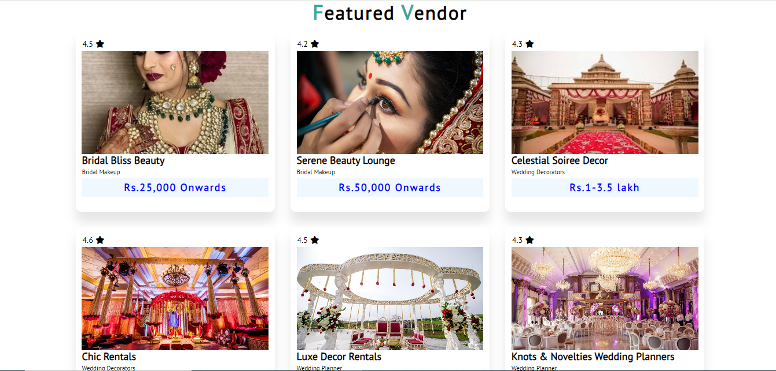

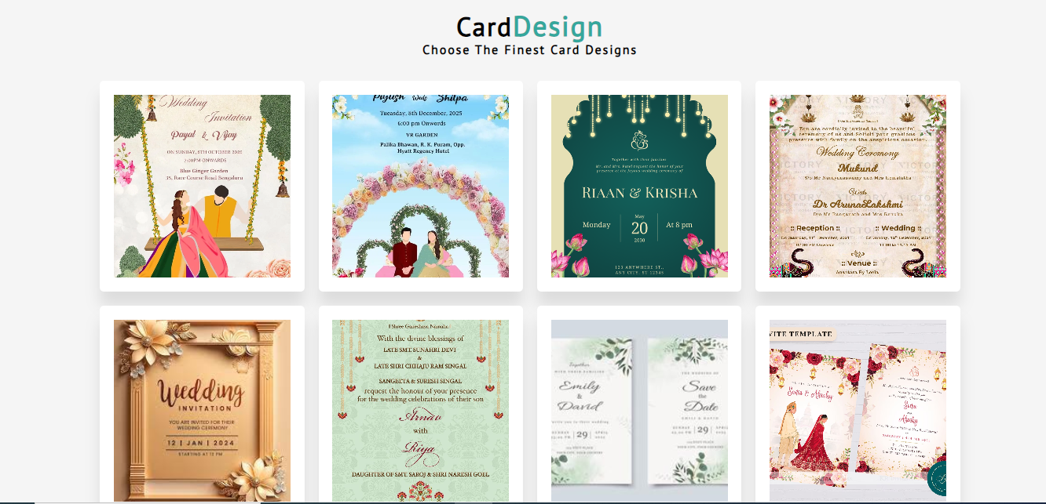

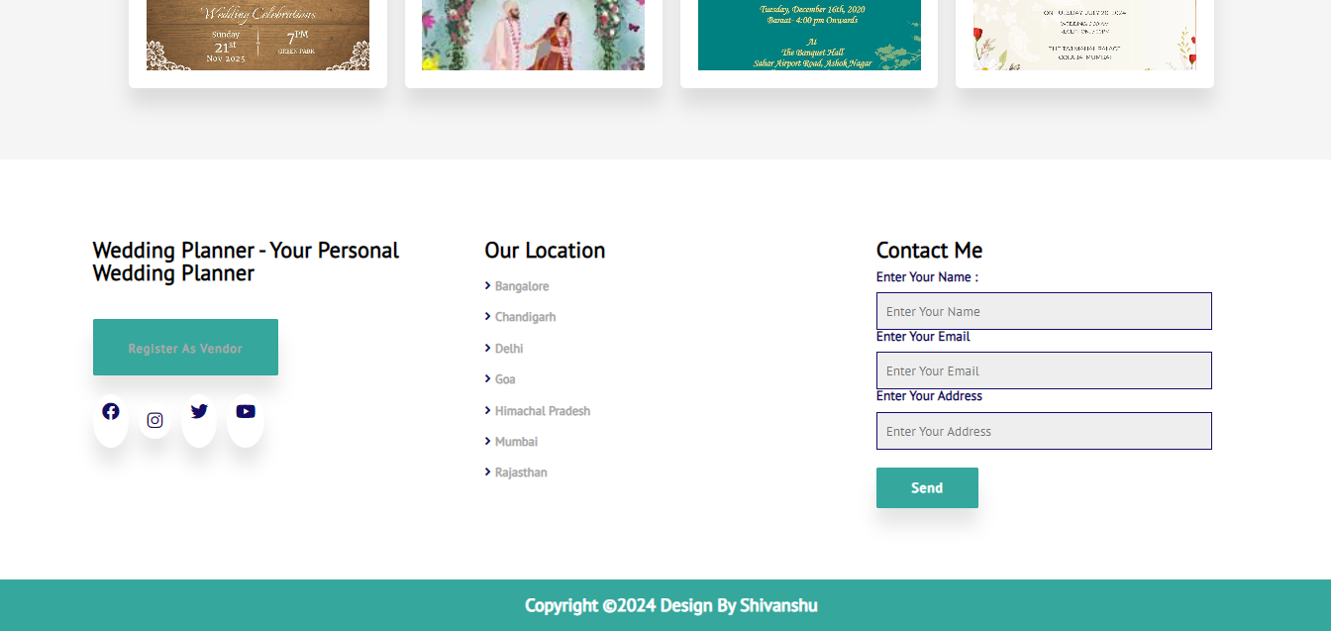

**LOGIN PAGE**

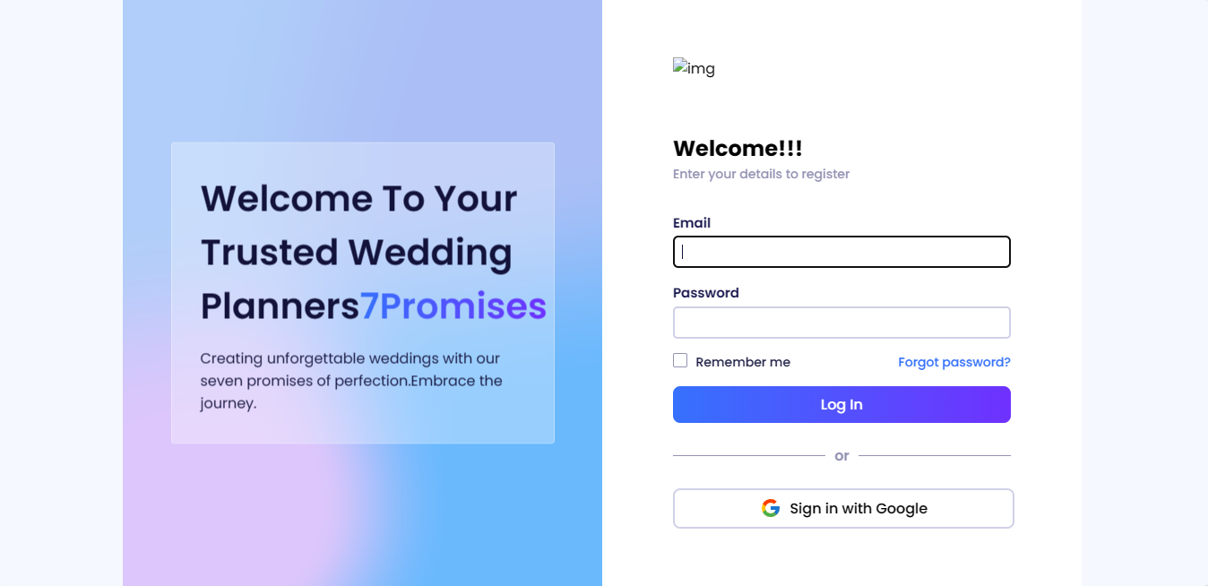

**TESTING**

Testing is a dynamic method for verification and validation, where the system to be tested is executed and behavior of the system is observed. Due to this, testing observes the failure of the system, for which the presence of faults can be deduced. However, separate activities have to be performed to identify the faults and then remove them.

There are two approaches to testing, functional and structural. In functional testing, the internal logic of the system under testing is not considered and the test cases are decided for the specification or the requirements. It is often called black-box boxing testing. In structural testing, the test cases are decided entirely on the internal logic of the program on module being tested. The externals specifications are not considered. Mutation testing is another approach for structural testing that created mutants of the original program. The testing criterion is to kill all the mutants by having the mutants by having the mutant generate a difference output from original program.

Unit testing is to test a module and the focuses are combined into sub-system which is tested. The goal here is to test the system design. Structural testing can be used for unit testing, while at higher level mostly functional, testing is used.

During the test case, execution phase the test cases are executed are various reports are produced for evaluations testing. The main output of the execution phase is the test log, the test summary report and the error report.

**Maintenance**

Maintenance is a provision, which include both improvement of system functions and correction of faults which arise during the operating of the system. Maintenance activity may require the continuing involvement of a large proportion of computer resources. When we install software, chances arise in two ways.

As a part of normal running system where errors are found, user may ask for improvement or external requirement change.

As a results of specific investigation and review of system performance.

**CONCULSION**

The project WEDDING PLANNER WEBSITE is web based wedding planning system to help organize successful wedding event. The system assists couples in decision making and planning processes associated with all aspects of wedding organization. The system offers features that couples can retrieve information for wedding products and services as well as information of vendors in shortest possible time.

Also, vendors can gain benefit of getting more recognition from clients and generating more revenue. The system enables wedding users to manage guest list, check list and task management. The user can request for pricing from vendors through the system and manage their budget for the big day. The system enables all users to access to it any time any anywhere.

# *BIBLIOGRAPHY*

During the project preparation time we took a help from our teachers, our group members and so many other sources that help us to made this project successful.

* **HTML AND CSS**

Website : [www.google.com](http://www.google.com)

Website : [www.w3schools.com](http://www.w3schools.com)

* **JAVASCRIPT**

Website : [www.google.com](http://www.google.com)

Website : [www.greeksforgreeks.com](http://www.greeksforgreeks.com)

Website : [www.youtube.com](http://www.youtube.com)

Website : [www.stackoverflow.com](http://www.stackoverflow.com)